Dear Valued Clients,
I am writing to let you know that I will be moving to a new location.
Effective August 1, 2026, all appointments will take place at:
370 University Avenue East
Waterloo, ON
New Phone Number: coming soon. Email stays the same.
This move is an exciting new chapter for Swelling Solutions. After many wonderful years in larger spaces, I have decided to downsize and move into a more collaborative healthcare environment. This change will allow me to continue focusing on providing specialized lymphatic care while working alongside other healthcare professionals, creating opportunities for collaboration that can benefit clients.
While the location is changing, my commitment to providing high-quality, evidence-based care remains the same.
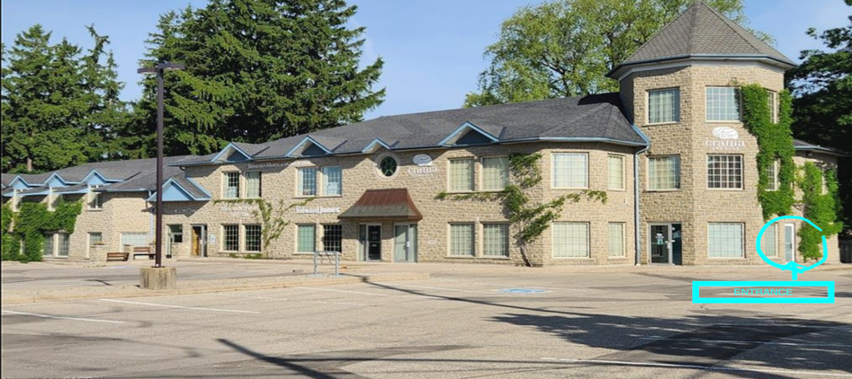

Entrance is at side of building

What to Expect When You Arrive
At my current office, you are accustomed to walking directly into the treatment area. At the new location, the process will be slightly different.
When you enter the main door at the side of the building (see picture above), please proceed left into the waiting room. I will come and greet you there when it is time for your appointment.

A Quiet Clinical Environment
Because the new space is shared with other clinicians and their clients, the clinic operates as a quiet professional environment. I kindly ask that conversations in the hallways and common areas be kept quiet and brief so that everyone can enjoy a calm and respectful atmosphere.
Once we are in the treatment room, we can continue our conversations and discussions about your care as usual.

Parking and Accessibility
There is plenty of FREE parking!!! A ramp is located near the front and a sidewalk leads to the side of the building.
I look forward to welcoming you to the new space and continuing to support your lymphatic health.
If you have any questions about the move, please feel free to contact me.
Warm regards,
Cathy Burt
Swelling Solutions

